**Inputting Data into Scan Unlimited**

📌 **Objective:**  
Upload raw data into Scan Unlimited to do bulk UPC to ASIN pairings.

For today’s example, we’re using:  
📄 z P3 ShopWSS Link Tags - 6.26.24

**🔍 Starting Point**

🔗 Go to:  
<https://app.scanunlimited.com/scans>

Click **"New Scan"**

Drag & Drop your input file or search for it

**📊 What the Data Looks Like**

Once uploaded, Scan Unlimited will show you a preview of the data.

This step is where we define how the matching works — and it’s **critical** to set it up properly.

**⚙️ Required Columns to Configure**

To ensure Scan Unlimited can run the match correctly, make sure you enable:

**🔍 Search By**

* Scan Unlimited is asking **HOW** it should search
* This tells Scan Unlimited to match against Amazon using the product’s UPC
* ✅ Set this to **UPC**

**🆔 Product ID Column**

* Scan Unlimited is asking **WHERE** the UPC column is located
* Set it to the name of your header in your file with the UPC
  + In our case, barcode

**💸 Cost Column**

* Scan Unlimited is asking **WHERE** the cost column is for profit calculation
* Set it to the name of your header in your file with the Cost
  + Sometimes we’ll list this as ADJ short for Adjusted

**📦 Custom Columns**

These don’t affect matching — but **will be included in the export**, which helps later during merging or analysis.

✅ **Always include**:

* Source URL
* Any custom column we want to be included in our data set
  + Example – Inventory, promo codes, color, size etc

**🧾 Note on Naming Conventions**

Let’s break down this file name:

📄 P3 ShopWSS **Tags Source** 6.24.24.csv

* P3 → Phase 3 of our system
* ShopWSS → The site we’re sourcing from
* Tags Source → The **custom columns** to include in the export
* 6.24.24 → The date the file was created

🧠 **Why include “Tags” and “Source” in the filename?**  
We want those columns are part of our export. By having the column names listed in the file name, we don’t have to remember every website’s custom columns.

**🔄 Maintain Naming Consistency**

To avoid issues during scripting and merging, try to keep your column names consistent across files.

✅ For example:

* Use UPC for your barcode column
* Use Source for the source link

🚫 Avoid switching it up (e.g., calling it Link in one file and Source in another).  
In the past, I used Link instead of Source, and that small change caused issues in the scripts — since we’re referencing specific column headers like UPC. Scripts will break if they are expecting one column name and gets another.

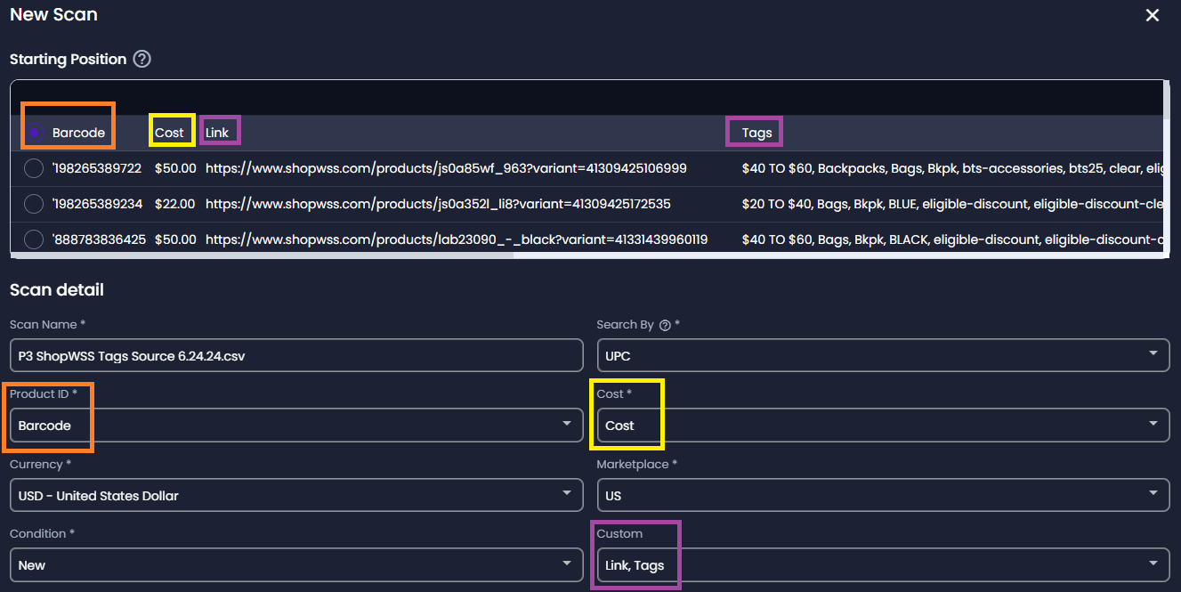

**🟢 Start the Scan**

Once everything is configured:

Click ✅ **Start**

Wait for the scan to process — this may take a few minutes depending on file size.

We’ll use the output data in our next steps